Alexa Mowbray, Ryan Cathcart, David Doman, and Jason Taylor

**Recruiting Advertising Strategy**

In February 2011, The Whitman School of Management launched a recruiting campaign utilizing Google ads and Delta Airlines’ magazine advertisements. The goal of this campaign was to stay under a budget of $100,000, as well as look at metrics such as GMAT scores to recruit the best students in the US. We wanted to look at Google analytics to see if there were any patterns or areas of improvement that we could identify. There were a couple of pieces of data that we analyzed: audience, acquisition, behavior, as visitor flow data.

There were four different campaigns that we looked to identify any opportunities with: whitman.syr.edu, MBA Marketing - Full Time, MBA Marketing - iMBA, and Delta.

1. **What were the time frames for each marketing campaign? How much was spent on each campaign? What was the effectiveness of previous campaigns? (40%)**
   1. **Whitman.syr.edu**
      1. **Timeframe** - Feb 26, 2011 - Aug 26, 2011
      2. **Cost** - The cost for this marketing campaign was $37,851.36. This sum was shared by two Campaign IDs:
         1. Whitman FT MBA - $37,699.45 ($4.03 cpc * 9358 clicks)
         2. LogTech - $151.91 ($0.55 cpc * 278)
      3. **Effectiveness of the Campaign** - due to the below reasons, we can conclude that this campaign is moderately successful:
         1. **Bounce rate** – measures the percentage of single-page sessions; i.e. during this visit the individual had no interaction with the page. This campaign had a bounce rate of 78%
         2. **Pages/ Session** – Average number of pages viewed during session is 1.84 meaning that on average individuals did spend time navigating the web page
         3. **Average session duration** – The average length of session was 47 seconds which is not a sufficient amount of time to research the program

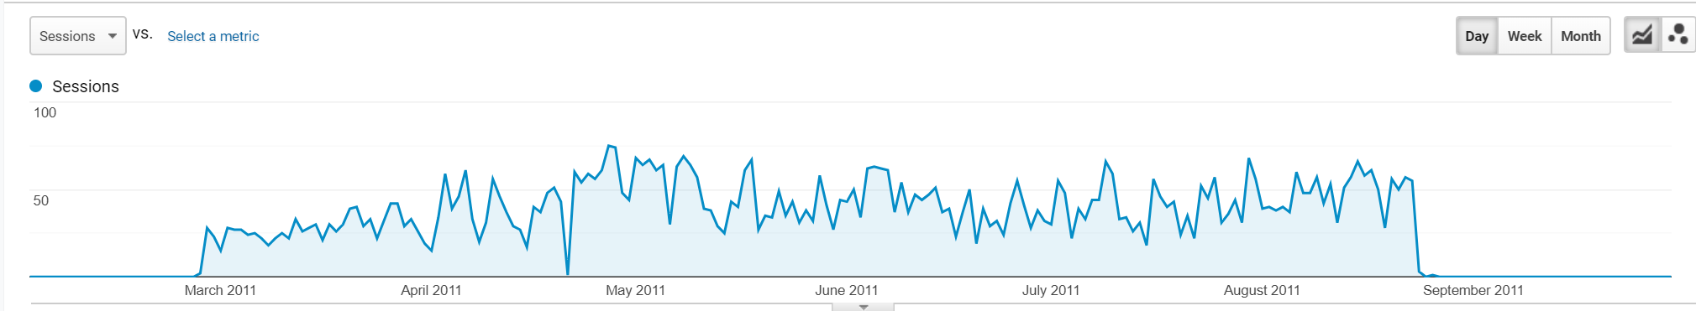

* 1. **MBA Marketing - Full Time**
     1. **Timeframe** - there are two timeframes for this campaign:
        1. Jan 1, 2012 – Feb 2, 2012
        2. Oct 26, 2012- July 11, 2013
     2. **Cost** - The cost for this marketing campaign was $166,376.77. This sum was shared by two Campaign IDs:
        1. Whit MBA - $59,324.51 ($12.32 cpc * 12,937 clicks)
        2. Whit MBA Display - $7,052.26 ($0.87 cpc * 8,116)
     3. **Effectiveness** - we can conclude that this campaign was very unsuccessful due to several factors:
        1. **Bounce rate** – The bounce rate for the Full Time MBA in Marketing program is extremely high at 97.7% which could have been the result for the campaign stopping just 30 days later. In comparison, the Bounce rate with the second campaign was 82.5% which leads us to believe that the second campaign was more successful than the first. The overall Bounce rate was 88.5%. These high rates paint a picture of an ineffective campaign.
        2. **Pages/ Session** – Average number of pages viewed during the first campaign was 1.03, meaning that almost no one who visited the site explored any deeper than the landing page. In comparison, the second campaign had a page per session rate of 1.27, with an overall rate of 1.21. Again we can conclude that the second half of the campaign was more successful than the first half, but still largely unsuccessful.
        3. **Average session duration** - average duration for this campaign was 26 seconds

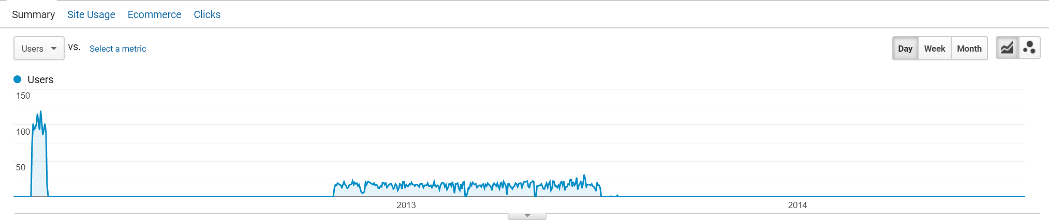

* 1. **MBA Marketing - iMBA**
     1. **Timeframe** - There is one timeframe for this campaign: Thursday, February 2, 2012 through Friday, October 26, 2012
     2. **Cost** - The cost of this campaign was $135,153.46 and shared by three campaigns:
        1. Whitman FT MBA at a cost of $37,699.45 (9,358 clicks * $4.03 CPC)
        2. Whit MBA at a cost of $97,302.10 (9,184 clicks * $10.59 CPC)
        3. LogTech at a cost of $151.91 (278 clicks * 0.55 CPC)
     3. **Effectiveness** 
        1. **Bounce rate** – Once again we analyze Bounce Rate to determine the number of users who leave before exploring the site. The program rate for the MBA Marketing - iMBA program is 89.5%. Higher than the Whitman.syr campaign, but lower for each Full Time marketing campaign
        2. **Pages Per Session** - Related to the Bounce Rate is the Pages per Session metric. The rate for this campaign is 1.13
        3. **Average Session Duration** – the average time spent on this site was only 19 seconds, which is directly correlated with the bounce rate and the page per session in this case. This amount of time leads us to conclude that the individuals who accessed this page did not stay long enough to learn more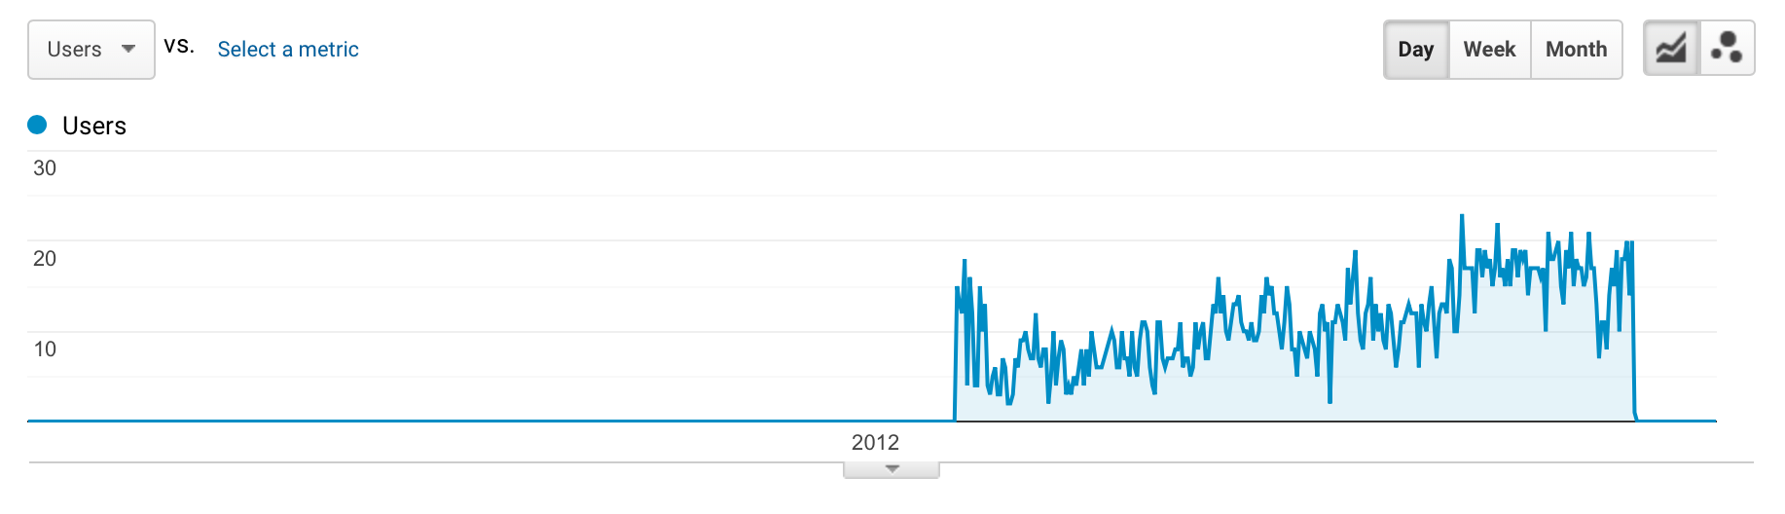

**D. Delta**

Based on the above information, we can conclude that the most successful campaign was Whitman.syr.edu. This campaign performed better in all categories investigated

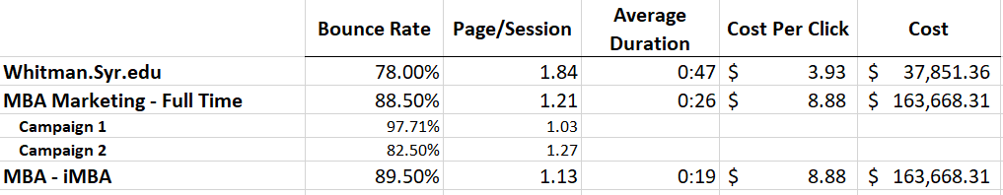

Compared to Whitman.Syr.edu:

* Bounce Rate was greater for MBA Marketing - FT and MBA - iMBA by 10.5% and 11.5% respectively
* Pages per session was less for MBA Marketing - FT and MBA - iMBA by 0.63 and 0.71 respectively
* Average Duration was less for MBA Marketing - FT and MBA - iMBA by 21 seconds and 28 seconds respectively
* Cost was greater for MBA Marketing - FT and MBA - iMBA as a whole as well as on a cost per click basis

**2. Identify the key aspects of a United States campaign for next year (20%)  
A. In which geographic region would you advertise? Which states? Why?**

We looked at the whitman.syr.edu campaign to identify some key trends to help our advertising plan for next year. We wanted to analyze a wider range of data to account for any month to month fluctuations the website might receive. For a date range of February 1, 2011 to December 31, 2011, there were 302,851 sessions in the US, making up over 74.54% of overall sessions. From a geographic region perspective, 5/10 states are located in the Northeast region, with New York composing 48.91% of the sessions for the site. Since half of the sessions are consolidated to one region, one suggestion would be to increase advertising in regions outside of this area to increase enrollment. Two top contenders are either California and Texas, which are the #2 and #3 top states, respectively.

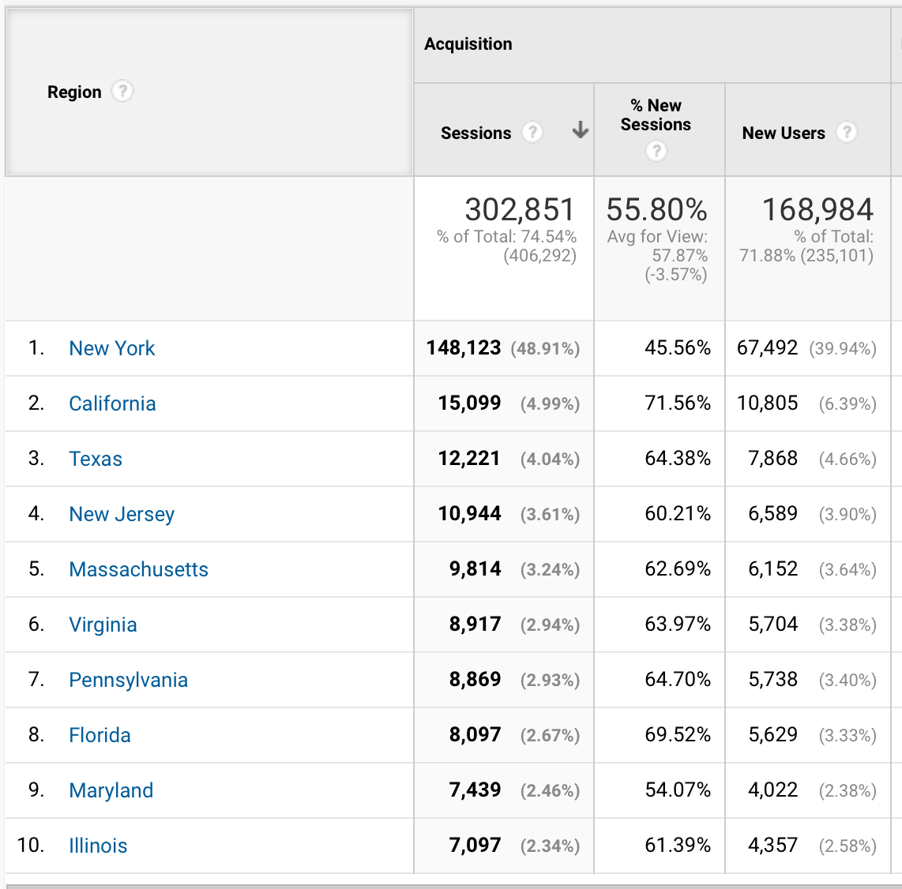

We also decided to explore the Bounce Rate, a metric which indicates the number of users in a particular area who navigate away from the site after exploring just one page. It is logical that some states, like Arizona, Illinois, South Carolina, or Washington have a higher bounce rate because of their distance from New York; however, it is surprising that New York has one of the highest bounce rates in the US region at 52.08%.

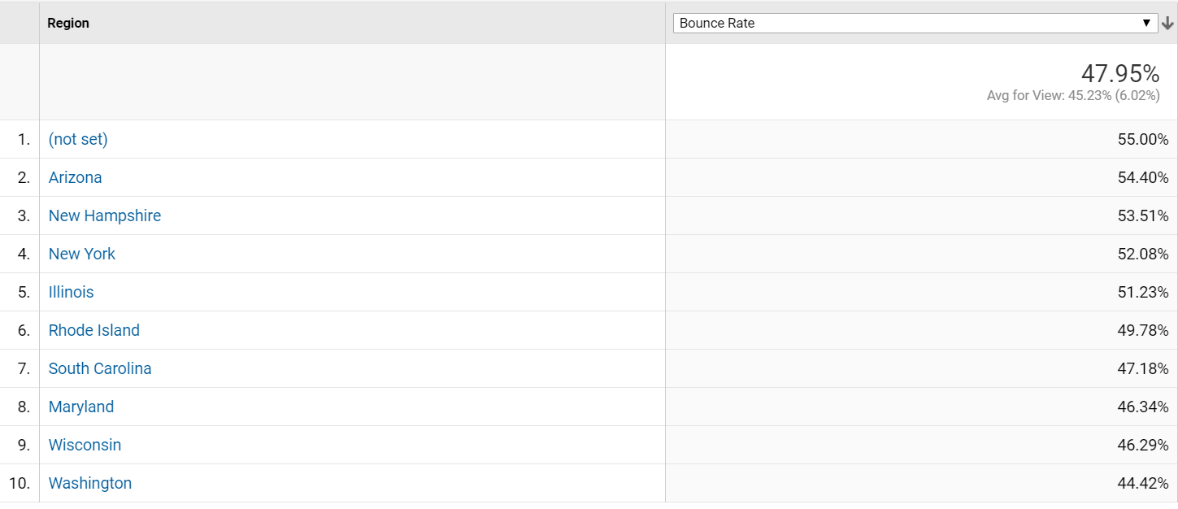

**b. What key words would you use? Why?**

Important keywords would include something similar to “Syracuse degree”. “Syracuse MBA”, “Syracuse Graduate”, “Syracuse Undergraduate”, etc. would be other keyword terms.

**c. Which days of the week and what time of day would you advertise? Why?**

I would advertise on the weekend as there is more traffic on these days. If advertising during the week, the hours with the highest traffic seem to be when people are leaving work for the day through early evening.

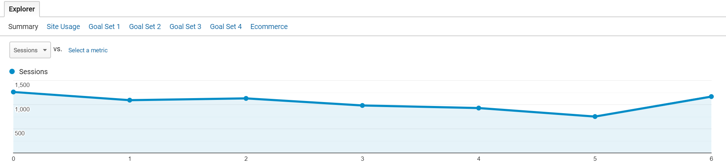

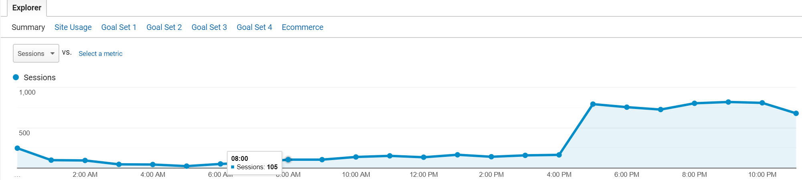

**3. Identify the costs for your advertising campaigns (10%)**

1. **By region**

The bulk of the costs should go toward advertising in New York as the university is located in this state. The further you are from the location, the less likely you are to attend. This state should also receive most of the dollars because of its high click rate. While this state has a high number of clicks, it also has a high bounce rate. This leads us to believe that there is interest in the university, and investment should be made in trying to maintain visitor attraction.

1. **By degree program**

We would choose to invest in the MBA Full Time program, MS in Finance, MS in Accounting, and iMBA. This is because these programs have the highest page per session, average session time, and relatively low bounce rate. These factors tell us that interest is high.

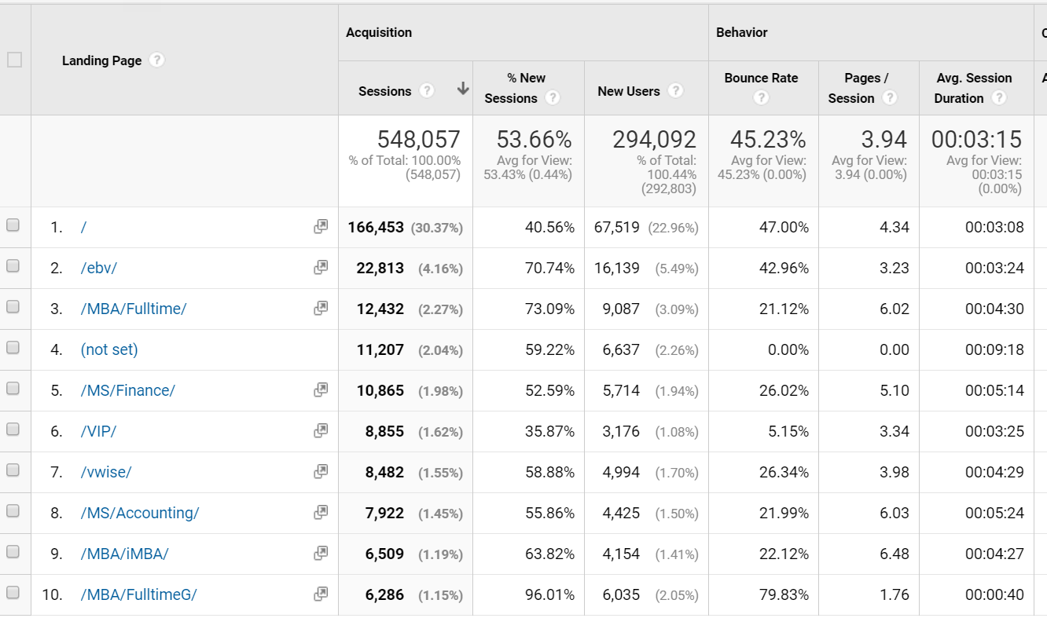

**4. How would you measure performance of your decisions after implementation? (20%)**

We would start by looking at the Audience metrics to show the new user utilization and returning user utilization. New user figures would tell us how attractive our decisions are and ultimately if they are actually working. Also, looking at the demographics to see what cities our campaign is attracting will tell us important information. Furthermore, looking at the way in which students are finding us is important to look at. Are students finding us using a computer or by mobile? Are they using a particular browser, operating system or service provider? For example, if we tailored our advertising to be compatible on an Apple operating system, we can check to see if what we implemented is actually working through this particular platform. These metrics can help us better to understand if what we’ve put out is effectively reaching our target audience the way we planned.

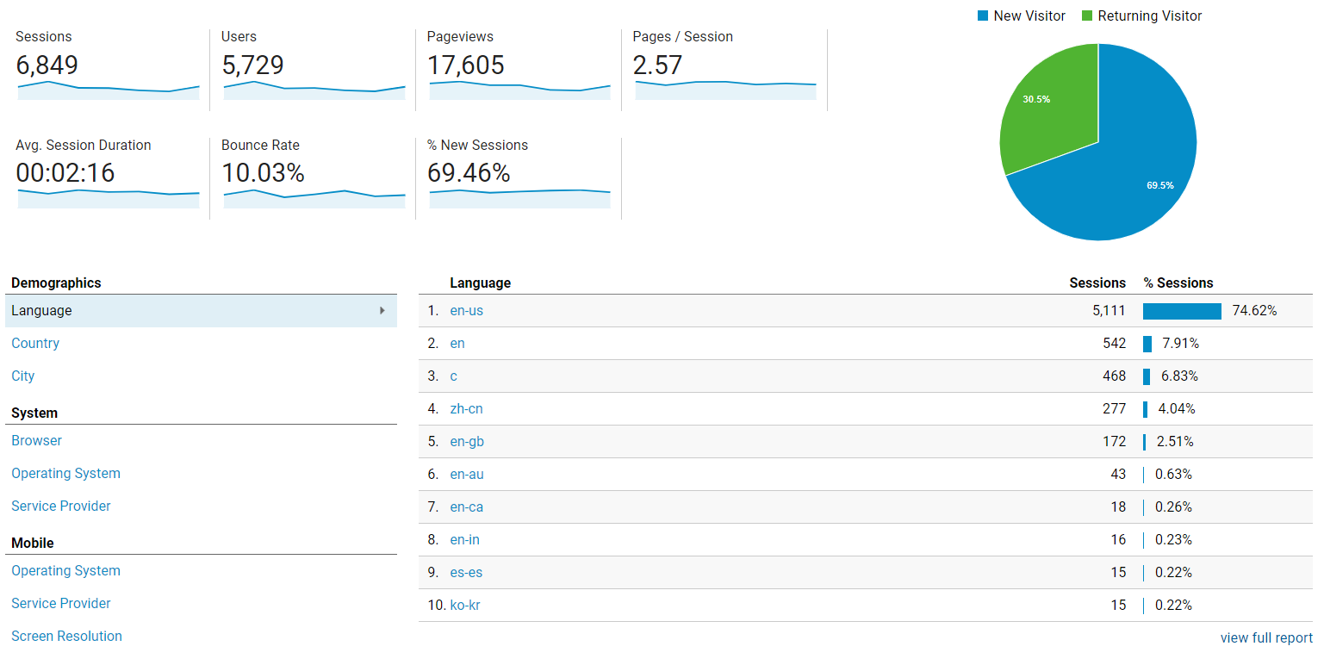

Next, we would look at Acquisition data. This can help us understand how students are finding us and if we need to alter the way we are advertising. Are they finding us through google searches, through social media, etc.? These metrics can help us better understand the way in which students are reaching us. We can also look at the various campaigns over time to see which ones have been the most effective. This can help us see which have done better than others and assist us in putting together future campaigns.

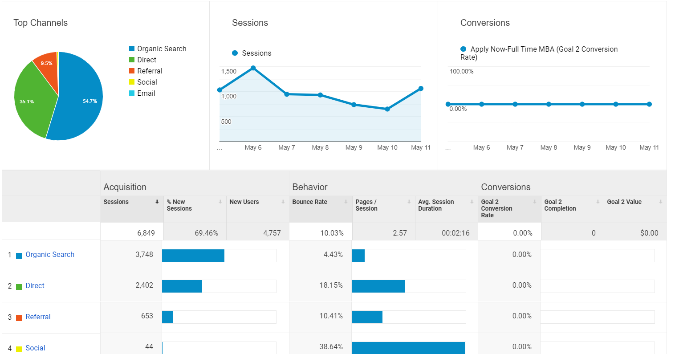

Third, we would look at the Behavior metrics. This can tell us how our users are navigating through our site after they’ve arrived. We can see if they go to the full time on campus page, the online education page, etc. We can better understand the type of students our advertising is attracting by viewing these numbers.

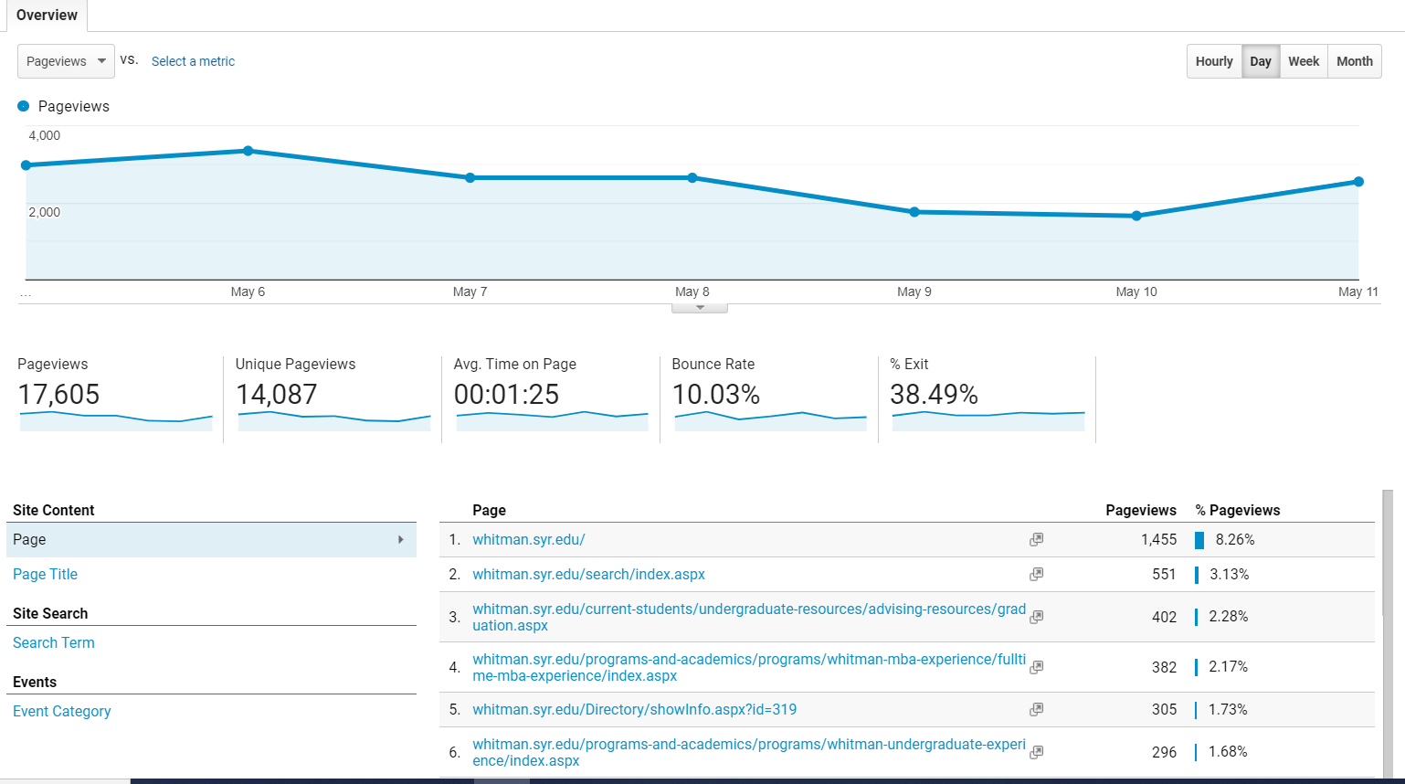

**5. What other factors or considerations are important? What other data would help in developing an Internet advertising strategy, if you could collect it? (10%)**

Other data that could be important include if a family member has previously attended the university, the number of students from a particular high school that attend the university, etc. Although not easily obtainable, having access to more personal information would be very helpful. This type of information is tough to access for many reasons, a main one being privacy issues. Access to this type of data would allow for more precise advertising directives and provide the most effective advertising campaign